What Is Electronic Software Distribution?
You will know ahead of time...
Distributions will be made only with the approval of your computing representative, and you will get an advance e-mail notification.

Periodically, software will be sent to your workstation electronically...
Electronic Software Distribution provides the ability to install software on a workstation without someone needing to physically touch the workstation.

It’s your choice...
Usually, you may choose to accept the download immediately, or postpone it until the next log on. See Box 5.
What you see...
On the day that a distribution is available, you will see a dialog box something like this when you log onto your workstation.

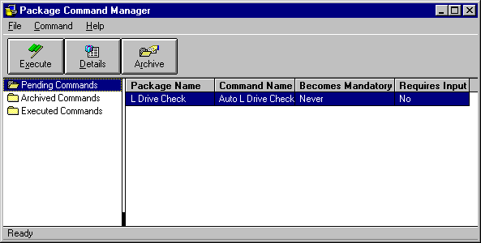

To start the distribution...
Follow the numbered boxes.
4.The Archive button moves the package to the Archived folder for use later without running the installation.

5.The date on which the distribution becomes mandatory. Some distributions will be mandatory right away. See Box 6.
2.The Details button shows more information about the package.

3.Click Execute to install the package.

1. Highlight the name of the software package.

Finally...
If you have trouble with your distribution, call for Help at 234-0911 (or 4-0911 from some locations). Or go to:
http://ispi.ca.boeing.com/comm/release/
releases/rel3-2.stm

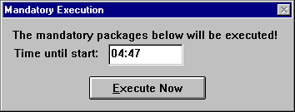
6. Mandatory jobs run automatically; you will see this screen, and have a 5 minute countdown before the distribution starts.
TS00XX.01

